  SCHOOL OF COMPUTER SCIENCE | COMP-2120, Summer 2025  Object Oriented Programming  Using Java  LAB-6  TOTAL MARKS: 10

LAND ACKNOWLEDGEMENT
The School of Computer Science at the University of Windsor sits on the Traditional Territory of the Three Fires Confederacy of First Nations. We acknowledge that this is the beginning of our journey to understanding the Significance of the history of the Peoples of the Ojibway, the Odawa, and the Pottawatomie.

SUBMISSION DEADLINE: Jul-14, 2025

GENERAL INFORMATION
Welcome to the Lab Session of COMP-2120 where you will learn object-oriented programming
(OOP) using Java. Please, arrive early to the lab and get settled to start working on the lab. Arriving 20 minutes after the start of the lab will be considered late and can affect your lab participation point. There are eight lab exercises you need to complete throughout the course. Each week on Monday morning we will publish the lab exercise. You need to upload your code by Monday, 11:59 PM in the next week.

LAB GRADING AND ASSESSMENT
You need to explain your code to TAs in the lab to receive the marks. YOU MUST demonstrate your results and explain the code to the TAs to receive marks. Thus, attending the lab sessions is mandatory. Note that your TAs are here in the Lab to help you learn. Feel free to ask questions and talk to them. Remember, the total Labs is worth 16% of your final grade.

Lab-6

In this example, we’ll build a Library System with different types of library items, such as books and DVDs. Each library item will have some common behavior (like checking out and returning) but may also have specific requirements for each type of item. We’ll use:
- An abstract class _{LibraryItem} to define common attributes and behaviors for all library items.
- An interface _{Loanable} for items that can be borrowed (checked out and returned).
- Concrete classes to represent different types of items, such as _{Book} and _{DVD}.

Part 1: Abstract Class LibraryItem (3 points)
- Create an abstract class LibraryItem to represent a library item.
- Attributes:
  - String title: The title of the library item.
  - int year: The publication or release year of the item.
- Methods:
  - getItemDetails(): An abstract method that displays the item’s details (to be implemented by subclasses).

Part 2: Interface Loanable (2 points)
- Create an interface Loanable for items that can be checked out from the library.
- Methods:
o checkout(): A method to check out the item. o returnItem(): A method to return the item to the library.

Part 3: Concrete Classes (3 points)
1. Create at least three classes that extend LibraryItem and optionally implement Loanable:
Book:
- Additional attribute: String author.
- Implements Loanable.
- Implements getItemDetails() to display book-specific details (title, author, year, availability). o
Magazine:
- Additional attribute: String genre.
- Does not implement Loanable (magazines are for reference only).
- Implements getItemDetails() to display magazine details and a note that it cannot be loaned.
DVD:
- Additional attribute: int duration (duration in minutes).
- Implements Loanable.
- Implements getItemDetails() to display DVD-specific details (title, duration, year, availability).
Part 4: Testing the System (2 points)
1. Create a main method in a LibrarySystem class to test the functionality:
Create instances of Book, Magazine, and DVD.
Implement a polymorphic method processLibraryItem(LibraryItem item) that
takes any LibraryItem and:
- Calls getItemDetails() to display details for each item.
- Checks if the item is Loanable using instanceof, and if so:
- Calls checkout() and returnItem() on the item to test loaning functionality.
- Displays appropriate messages for loanable and non-loanable items. Example Output:
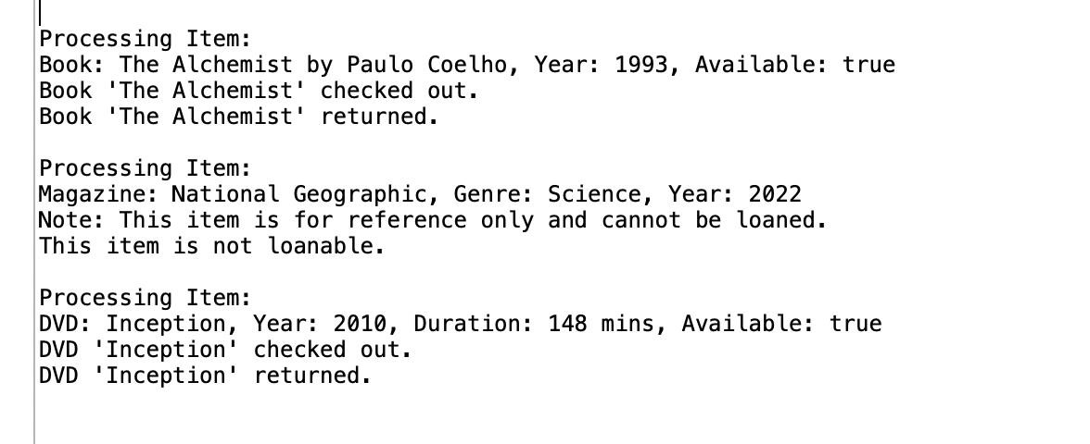

WHAT DO YOU NEED TO DO?
- Complete the program.
- Attend the lab. Explain the code and the purpose of using different OOP features to a TA.
- TAs can modify the input to your program.

